# **Exercise – D3 Data Visualization using TreeMap**

**Student Name: Student Id:**

**Date:**

Please use the screenshots ONLY as a reference. The instructions have to be followed AS-IS.

### Objective:

The objective of this exercise is to visualize university’s food data using D3 and to visualize it using one of the hierarchical maps in D3.

**Step 1: Create a new folder and HTML file**

* In eclipse open project Student_Name_D3 created in previous exercise
* Create a new folder ‘D3-Data Visualization using TreeMap’ inside this project
* Create a new HTML file “index.html” inside this folder

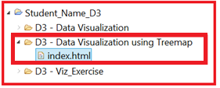

* On creating new html file in eclipse you will get the following HTML file template

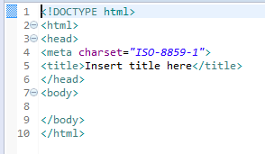

* Make following changes to this template
  + Change title to ‘Student_Name- D3 Viz’ and load D3 library

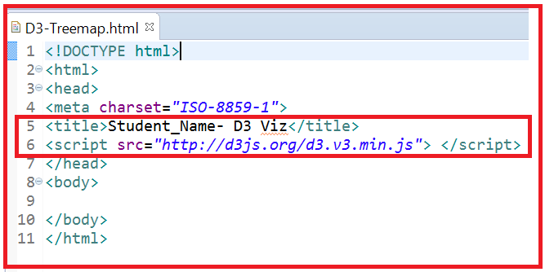

**Code Explanation**:

* + Adding title using title tag
  + Loading D3 library using link ‘http://d3js.org/d3.v3.js’ so that D3 functions can be used in this HTML page

**Step 2: Download dataset from ELearning**

* Download the ‘food_court_filtered.csv” file from eLearning and save it in above created folder.
  + Windows Users:

To access D3-Data Visualization folder, navigate to the following path



* + Mac Users:

To access D3-Data Visualization folder, navigate to the following path:

**Localhost folder (Desktop)** -> **Student_Name_D3** -> **D3 – Data Visualization using Treemap**

**Step 3: Upload the dataset using D3**

In this section you will upload the csv data using d3 and then prepare a nested data needed for the D3 Treemap.

* Write the following code in index.html within the script start and end tags (<script> </script>) in order to upload the csv data.

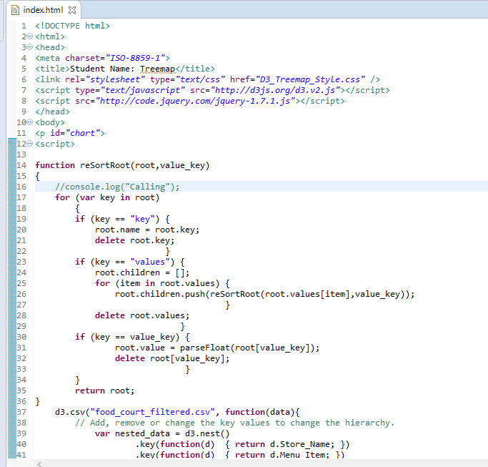

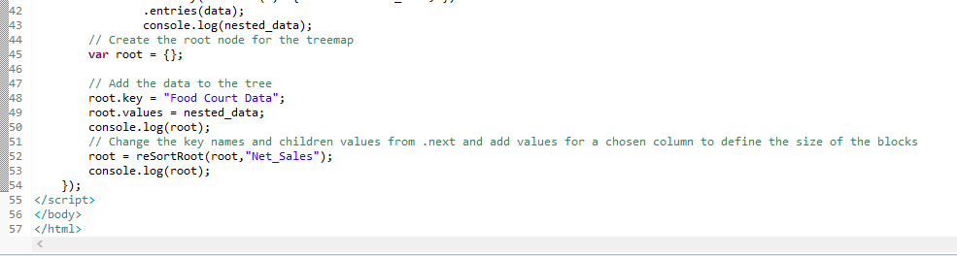

**Note:** Comments are provided above each section to understand the coding. You can play around with the settings and view the changes on your web page

**Question:**

1. **Open your HTML page in WEB browser and take a screen shot of your page showing page Title (your name) and page background.**

**Answer**

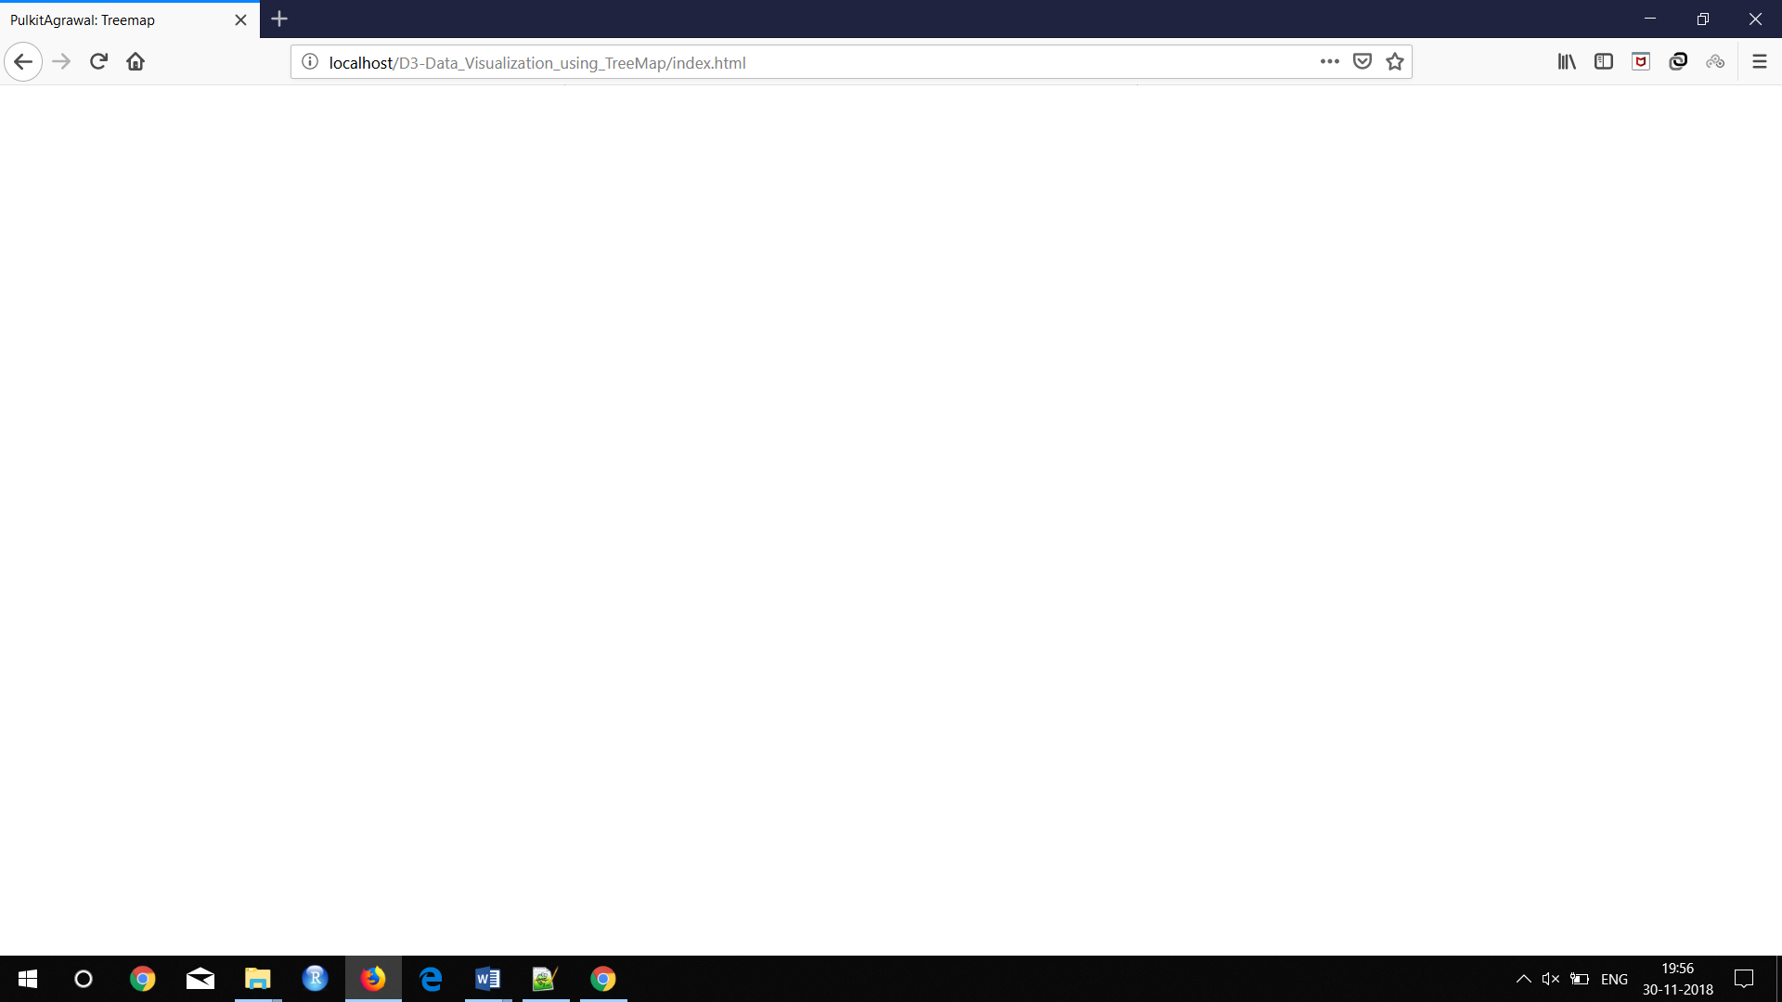

**Step 5: Create CSS**

In this step you will **create** a new CSS stylesheet D3_Treemap_Style.css inside “Data Visualization using Treemap” folder. This file will provide style to your webpage.

* **Right click** on “Data Visualization using Treemap” folder, **click** new and then **click** “other”. **Type** “CSS” in the wizard field. **Click** next, **maintain** filename as “D3_Treemap_Style.css” and then click “finish”.
* Link CSS stylesheet “D3_Treemap_Style.css” to the “D3_Treemap.html”.
  + Write the following code in the “D3_Treemap.html”

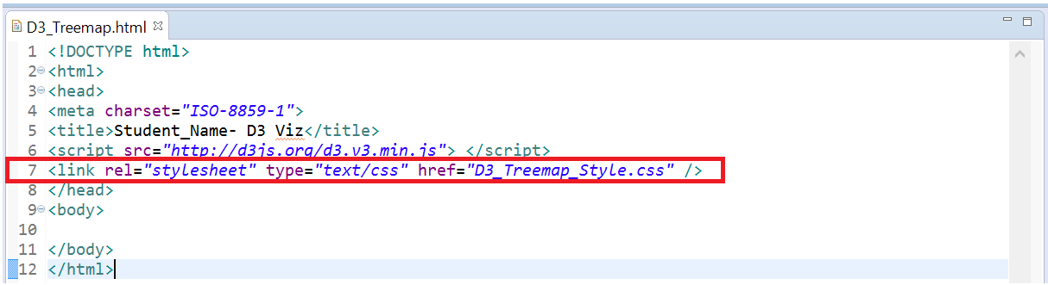

**Step 6: Create a JavaScript file (.js file)**

* **Right click** on “Data Visualization using Treemap” folder, **click** new and then **click** “other”. **Type** “JavaScript” in the wizard field, select “JavaScript Source file” then c**lick** next. **Maintain** filename as “D3_Treemap_JavaScript” and then click “finish”.
* **Link** the JavaScript file to the index.html file by adding the following code in **index.html** file.

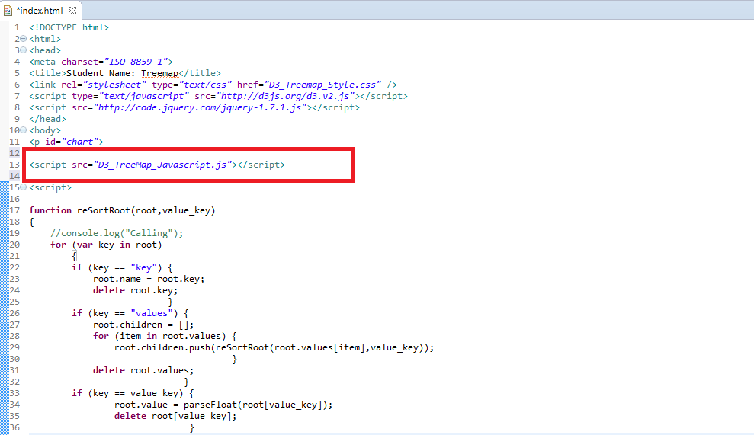

**Step 7: Create an SVG Container for the Treemap**

* Write the following code in the “D3_Treemap_Javascript” file.

In the below code we are creating margins for the chart. And then we are assigning these margins to the svg container which will hold the treemap. For any chart to be created you should first assign an image container. Here you are assigning the height and width of the svg image container.

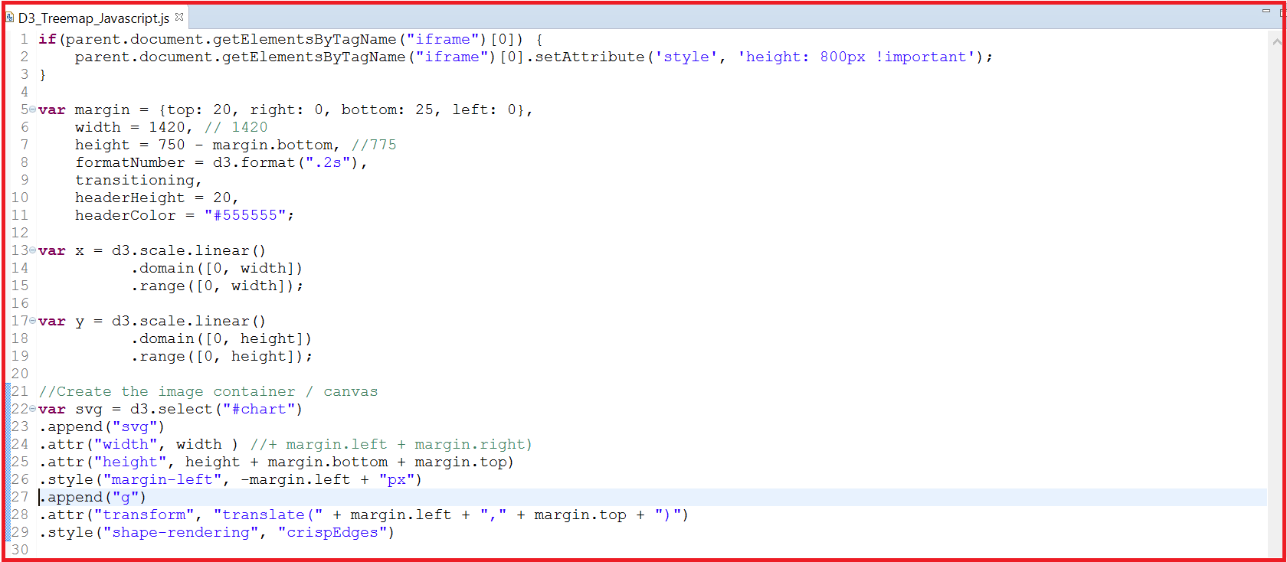

In order to view the svg container in the html page, type local host and the respective folder names to open your file in the browser and then open the developer tools as highlighted in the D3 Basic exercise.

In the developer tools, within the elements tab, you will be able to see the svg container created for the html page as highlighted below. As soon as you select a particular html element it will highlight that object in the browser.

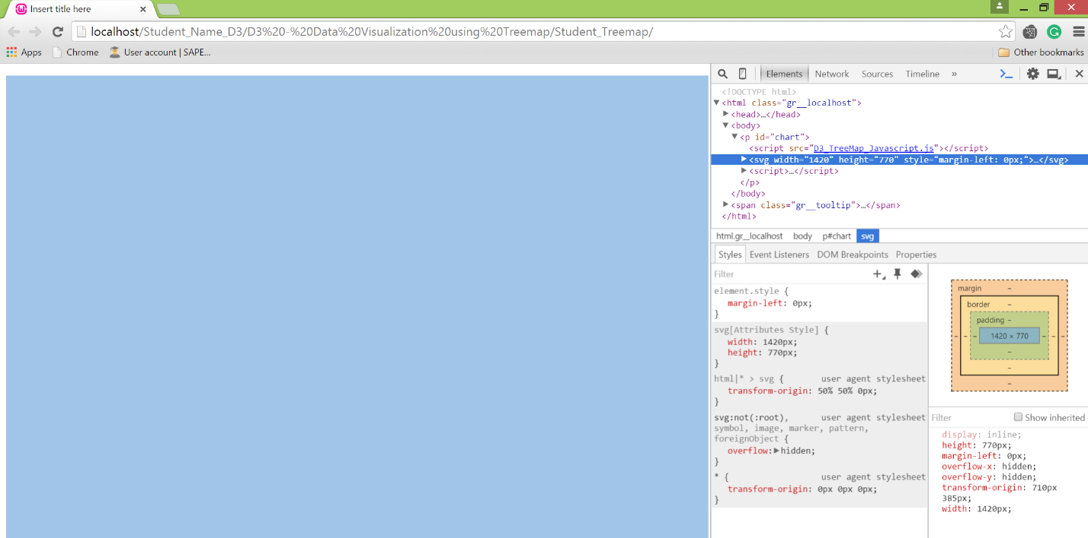

**Step 8: Create a layout for the Treemap**

There are a no. of hierarchical charts in d3 and each of them requires a layout to be created. Treemap is also a type of hierarchical layout. In this step you will be creating a layout for the TreeMap.

.

* Write the following code in the “D3_Treemap_Javascript” file, to create a treemap layout.

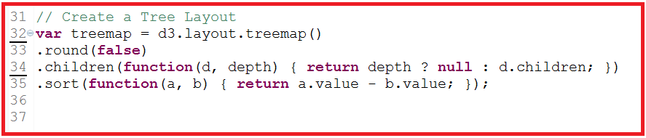

**Step 9: Create SVG image to display header data**

In this step you will be creating a rectangle to display header data and define the dimensions of that rectangle. You will also define the area to enter the text within the rectangle. This header will contain the heading of your treemap and when you navigate from one screen to another it will highlight the parent of the object that you have clicked on.

* Create the header rectangle and display text within the svg container.  
  Here we are creating a rectangular area by creating a rectangle and assigning dimensions to it. Then assigning the dimensions for the header to the text.

Write code in “D3_Treemap_Javascript” file

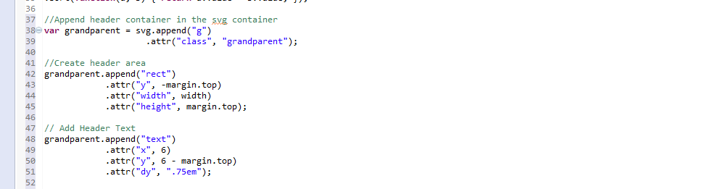

After adding the code, open the html page and you will be able see that a rectangle is created at the top of the html page. You can also view the creation of the grandparent element in the developer tools elements tab.

**Hint:** Open the developer tools in your browser, click on the elements tab and select rect under grandparent class as highlighted in the below screen shot. You will be able to view the header rectangle highlighted at the top of your web page.

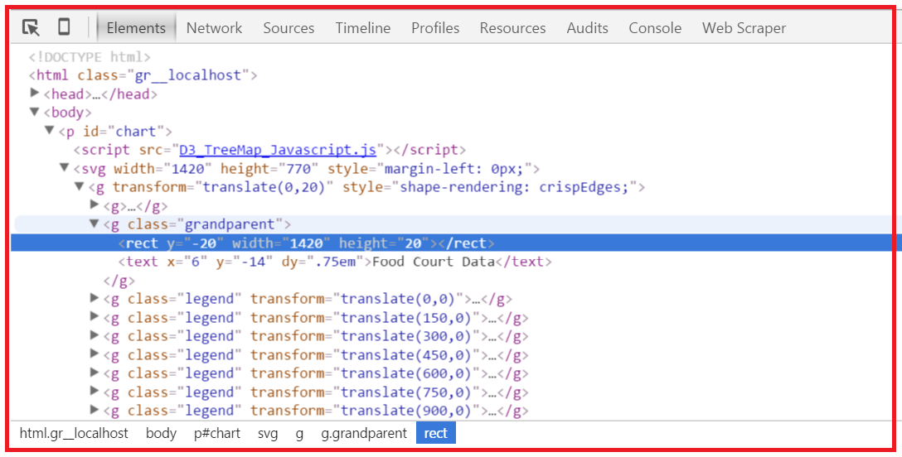

**Question**

1. **Paste a screenshot**

**Answer:**

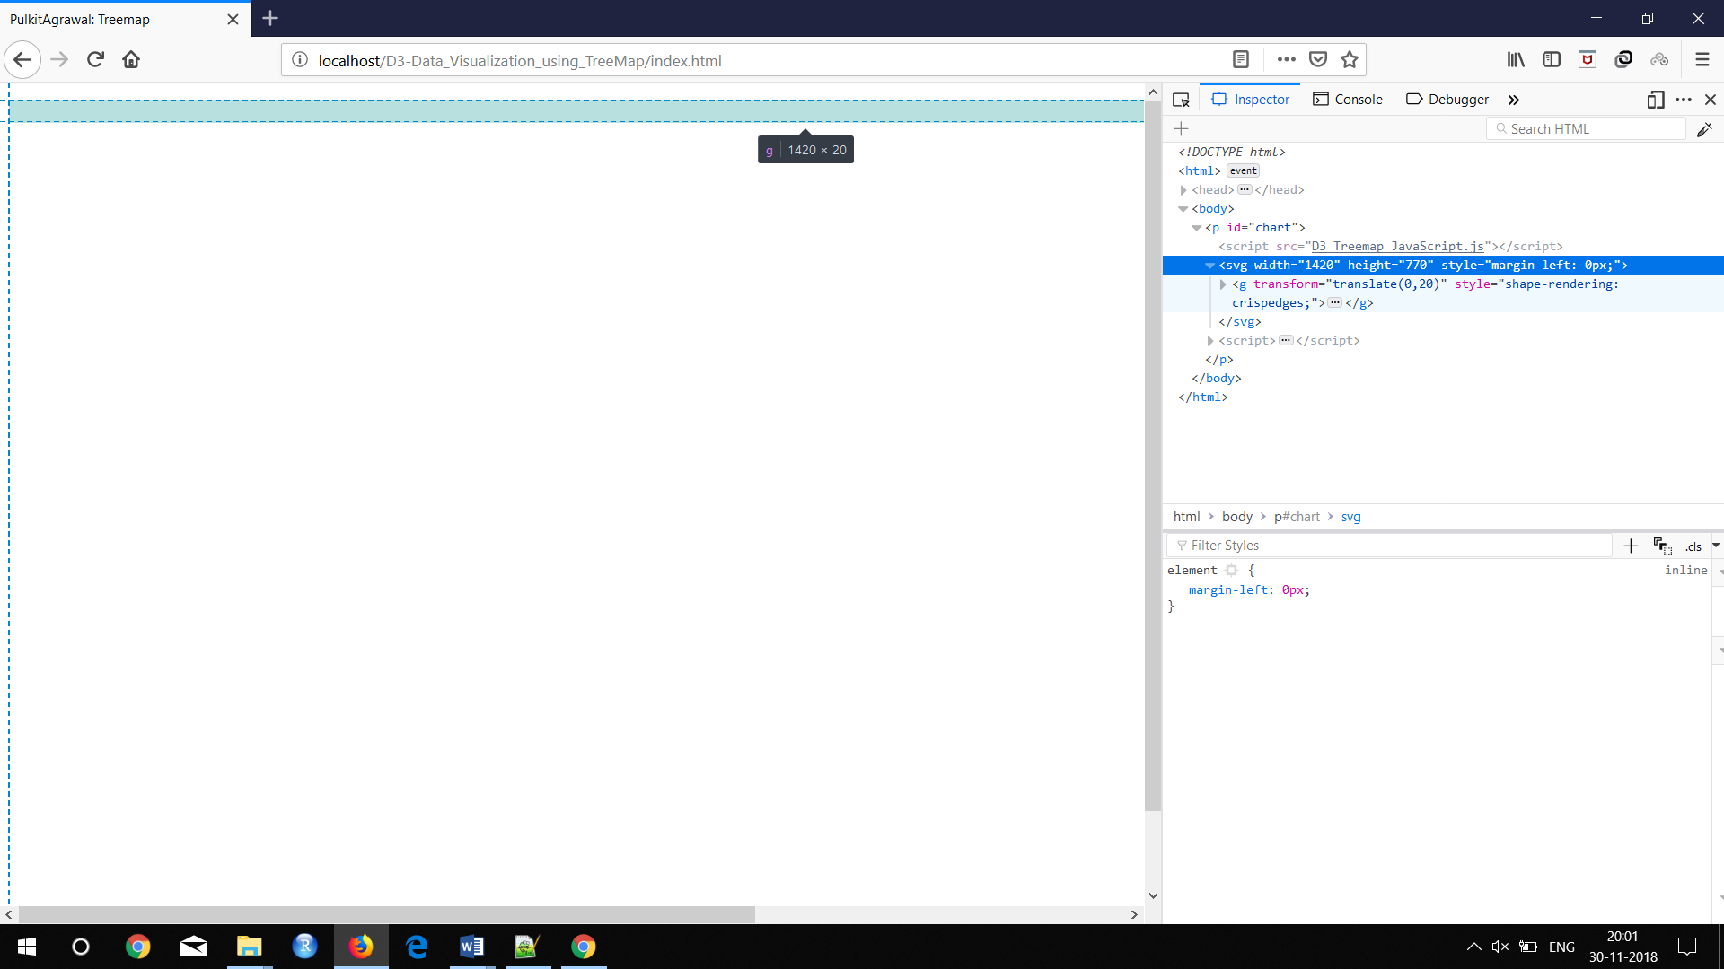

**Step 10: Load data into the Treemap**

* Create a function in D3_Treemap_Javascript.js file to load the data into the treemap and call that function in index.html file.
  + Write the following code in index.html

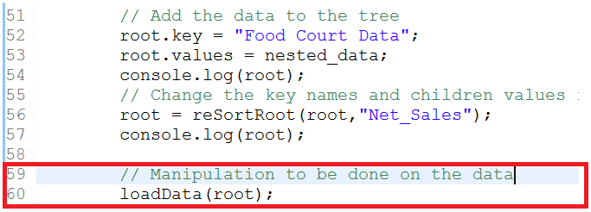

* Create a loadData () function in D3_Treemap_Javascript.js file, add the following 3 functions/methods highlighted in red.

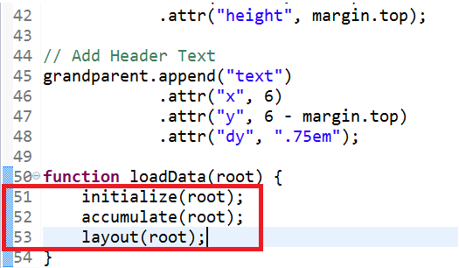

* Write the following code highlighted in red for each of the functions defined in the loadData function.

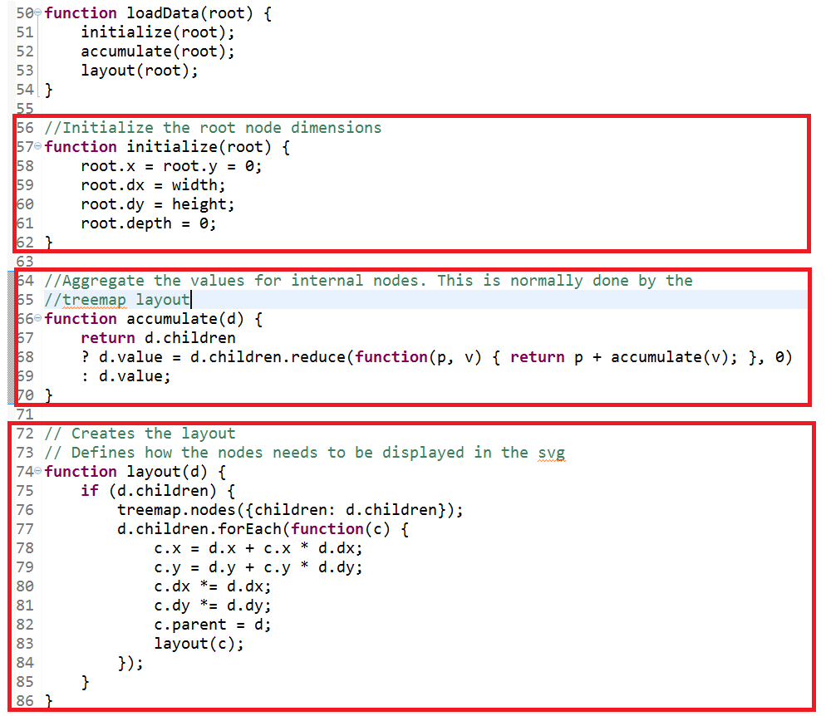

**Code Explanation:**

* Initialize function is initializing the dimensions of the root node which contains the nested data.
* Accumulate function is aggregating all the nodes within the parent node to display the value the aggregated net sales for each store.
* Layout function defines the placement of each of the nodes within the svg container

**Step 11: Create a basic functions to design the treemap**

* Write the following code highlighted in red in the D3_Treemap_Javascript.js file.

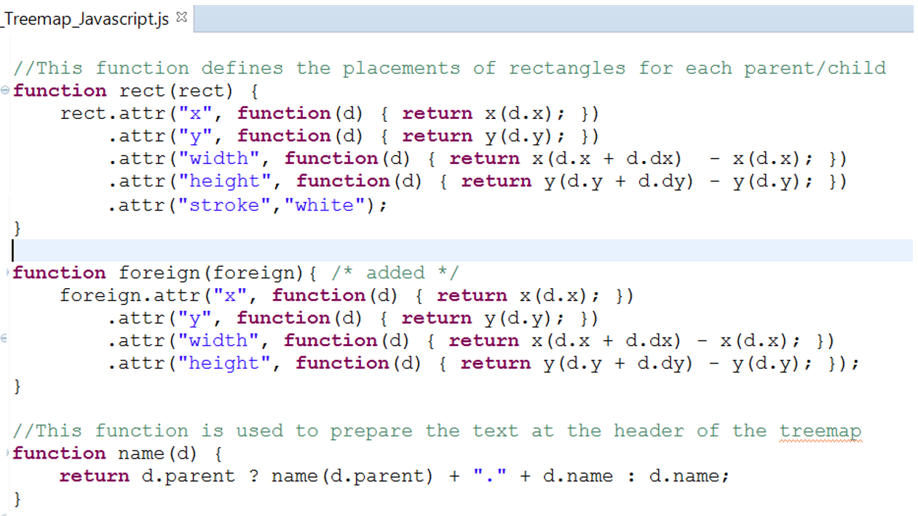

**Code Explanation:**

* The rectangle function defines the positioning of rectangles for the parent and the child nodes by assigning the attributes such as height, width, x and y coordinated. Also define the stroke to separate different nodes.
* Foreign function defines the zoom in/out functionality to view all the child entries within a parent.
* The name function assigns the name to the treemap header

**Step 12: Create display function**

In this section you will be defining the display function in your D3_Treemap_Javascript.js. Here you will be creating the rectangles for header (grandparent), parent and child and assigning text to the child rectangles.

Write the following code to define a display function.

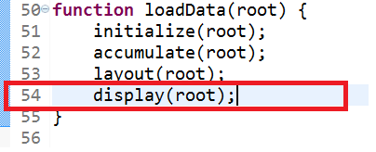

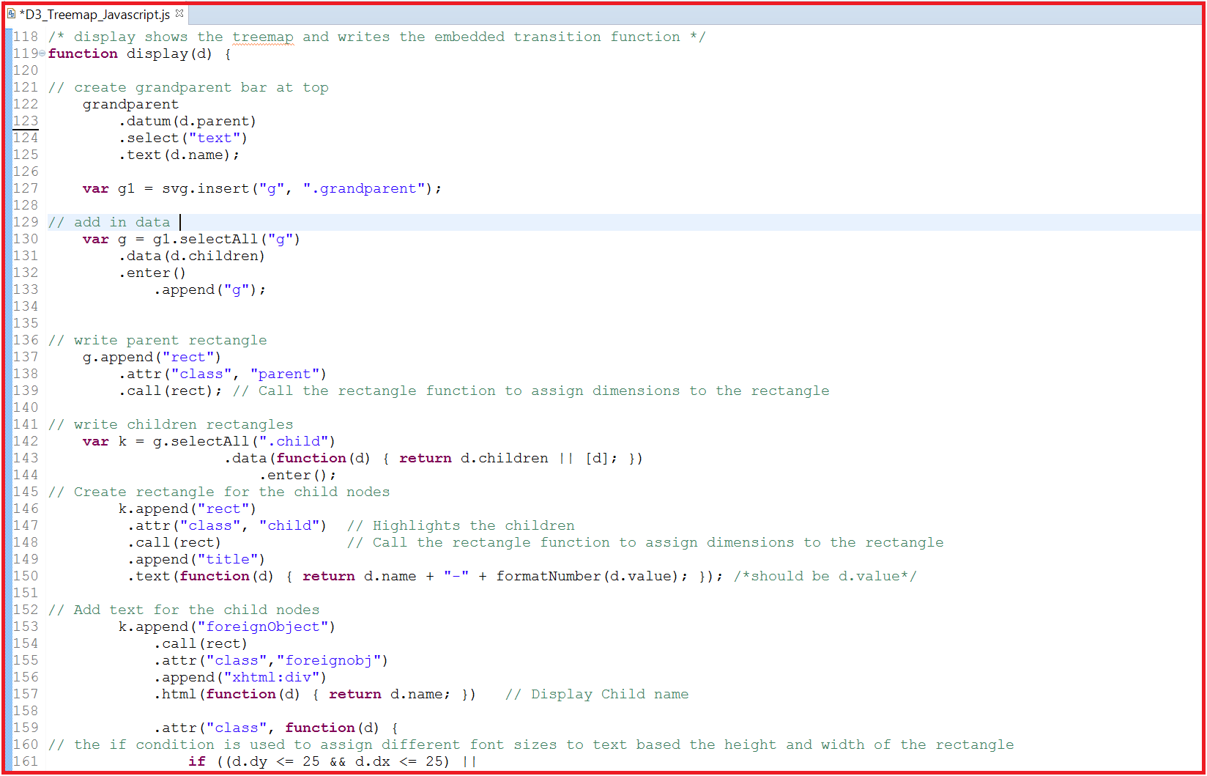

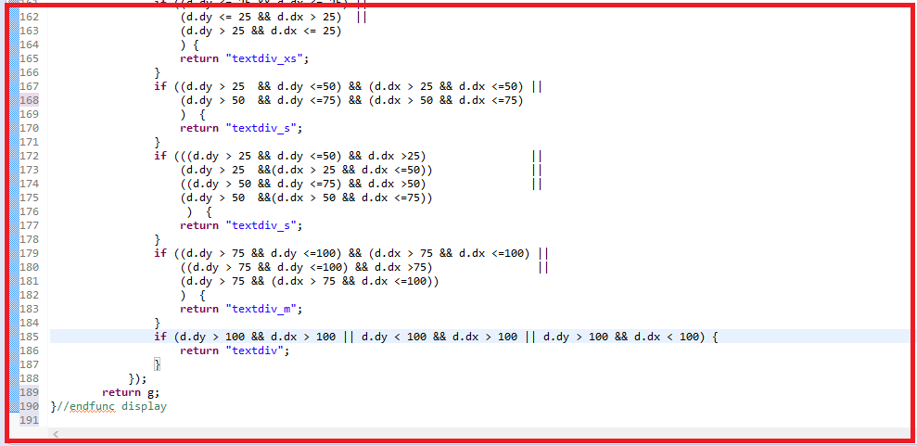

**Code Explanation:**

* Assigning text to the header of the treemap. Creating a separate group element for the header within the svg container. This is important to assign different actions to each object.
* Creating a separate group element for the parent and assigning data to it. Building parent rectangles using the **rect** function.
* Creating child elements within the parent element. Building rectangles for each of the children and assigning text to them.
* Text size is based on the size of the rectangle, bigger the rectangle bigger the font size of the text.

**Question:**

1. **Open the web browser, open your web page and paste the screen shot of your page.**

**Answer**

**Step 13: Define text size**

Open the D3_Treemap_Style.css file and write the below code to assign different text sizes, font as well as alignment for the text in the child nodes. In the javascript file we have used .textdiv, .textdiv_s classes etc. We need to create these classes in the css file (D3_Treemap_Style.css) in order have the different text sizes.

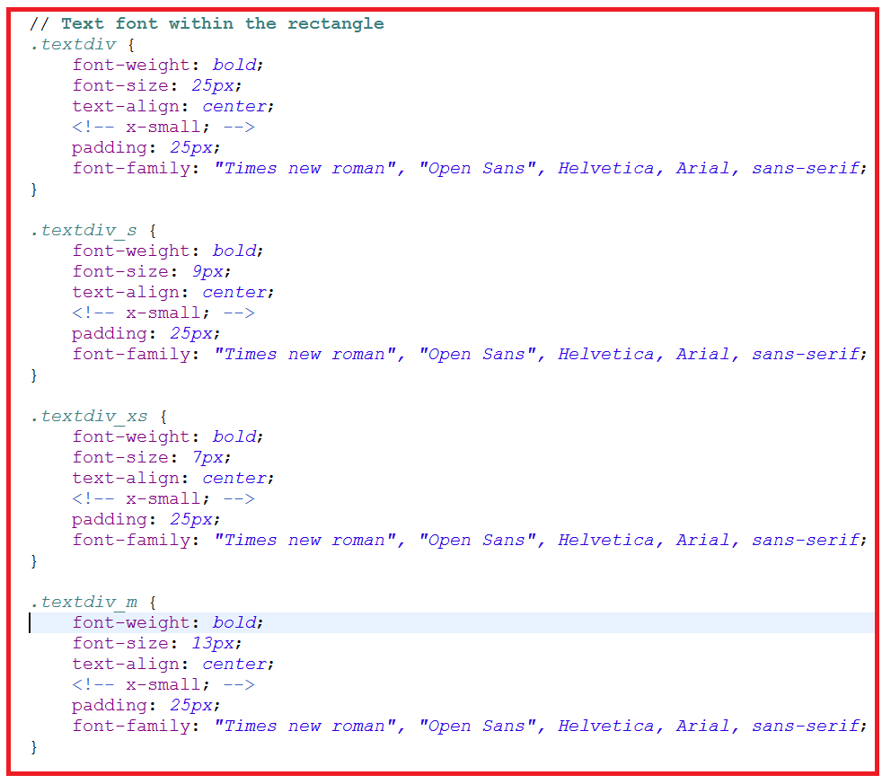

**Question:**

1. **Open the web browser, open your web page and paste the screen shot of your page.**

**Answer**

**Step 14: Define Chart class in CSS**

Open the D3_Treemap_Style.css file, and write the below code. This code is usedto assign the dimensions to the chart class used which defining your svg image.

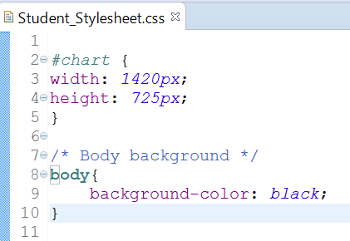

**Question:**

1. **Open the web browser, open your web page and paste the screen shot of your page.**

**Answer**

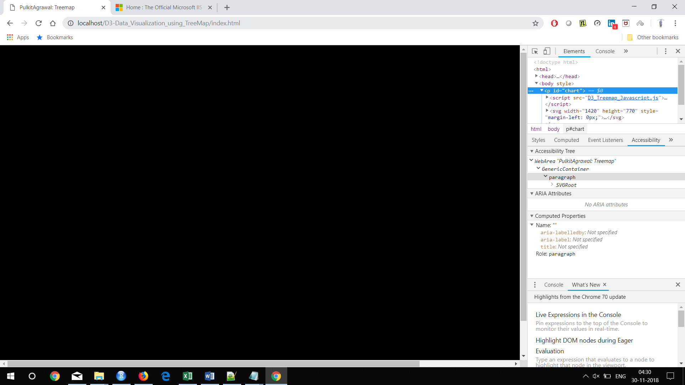

**Step 15: Assign color coding to the parent rectangles**

In this step you will be assigning color to the rectangles creating for the parent/child nodes. Here we will be defining the color based on the parent node.

* Write the below code highlighted in red in index.html file.

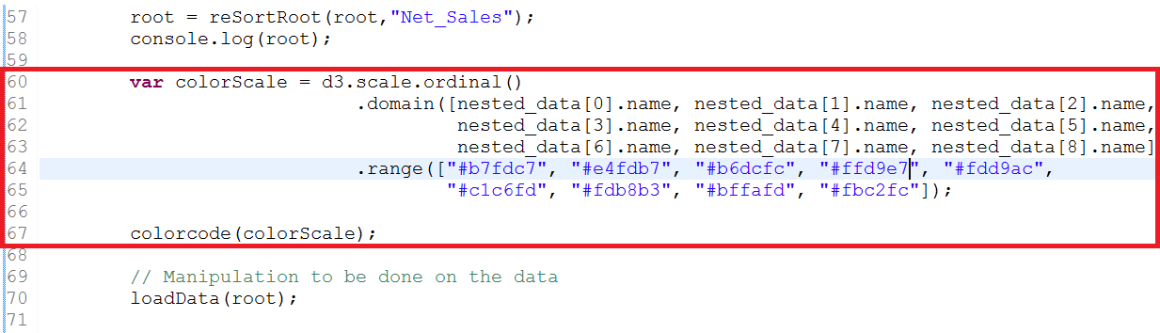

* Write the below code highlighted in red in D3_Treemap_Javascript.js file. Here we are creating a variable to store the color codes defined in the index.html file.

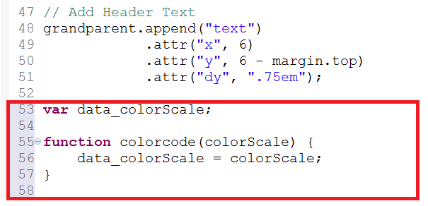

* Finally assign the color code to the rectangles by writing the below code in the rectangle function.

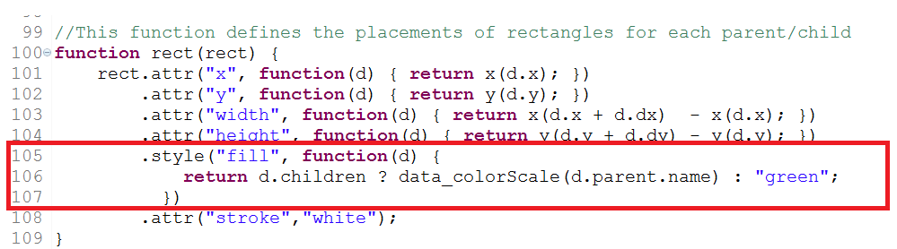

**Question:**

1. **Open the web browser, open your web page and paste the screen shot of your page.**

**Answer**

**Step 16: Assign Color to the header rectangle**

Although you have added the code for the header rectangle however it is still not visible. So in this step you will add color to the header rectangle.

Write the below code in your D3_Treemap_Style.css. Save the file and adding the code.

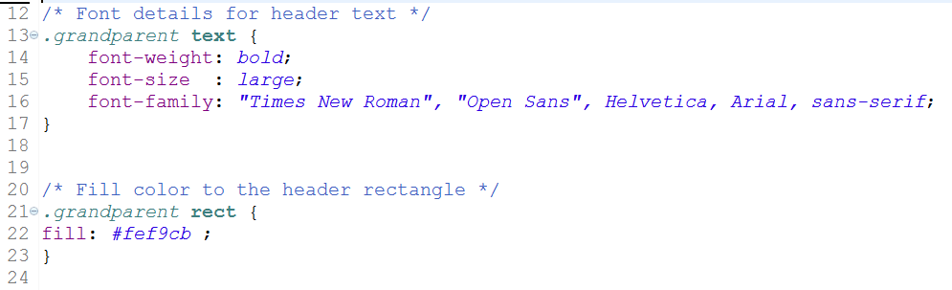

**Question:**

1. **Open the web browser, open your web page and paste the screen shot of your page.**

**Answer**

**Step 17: Create Legend**

In this step you will be creating a legend for the treemap. As highlighted early that each parent is displayed using a specific color. So the legend highlights which parent signifies which color.

Write the following code highlighted in red with **display** function in the same sequence in D3_Treemap_Javascript file.

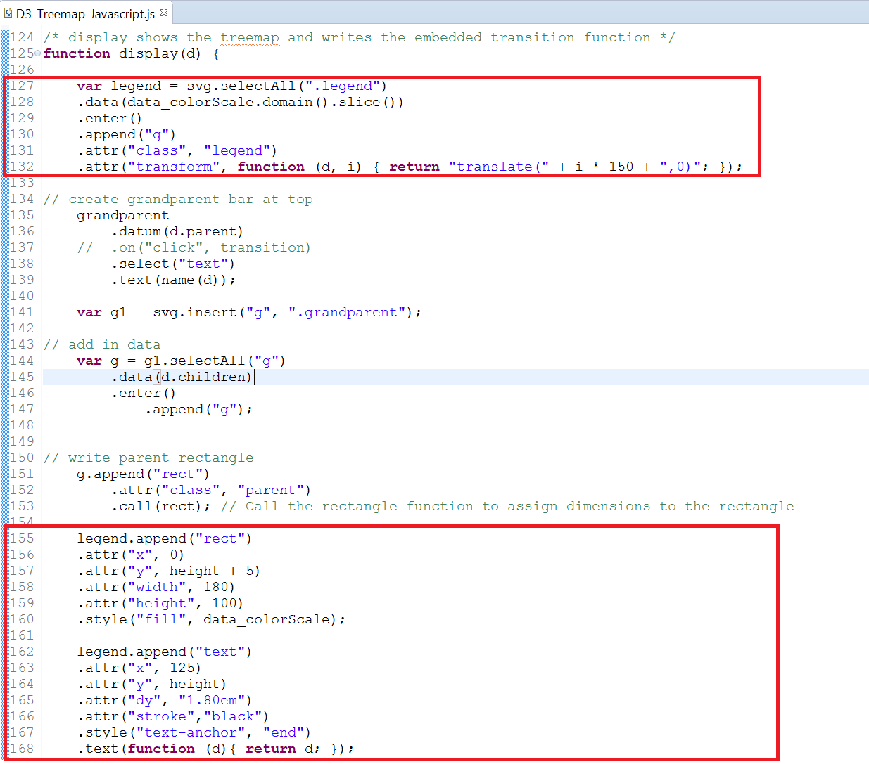

**Code Explanation:**

* + In order to display the legend, we need to follow the below steps:
  + Create a svg element for the legend, assign the color scale in the form of data in order to display different colors for different legend rectangles. Create a legend class in order to add styles and formatting to the rectangles and corresponding text in it. Assign size of each rectangle.
  + Create rectangles for the respective parents and then assign text to it.

**Question:**

1. **Open the web browser, open your web page and paste the screen shot of your page.**

**Answer**

**Step 18: Align the legend text**

In this step you will create a legend class in the D3_Treemap_Style.css file. This class will format the text in the legend.

Write the following code in the css file.

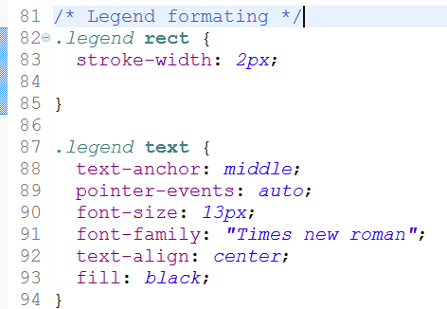

**Question:**

1. **Open the web browser, open your web page and paste the screen shot of your page.**

**Answer**

**Step 19: Create Transition**

In this step you will create navigation / transition, i.e. when you click on any colored rectangle you will be taken to a new screen which will zoom into the children of the parent. And when you click on the header, it will navigate back to your initial screen.

Write the following code in the D3_Treemap_Javascript.js: Place this section of the code within the **display function**, just before the **statement return g;**

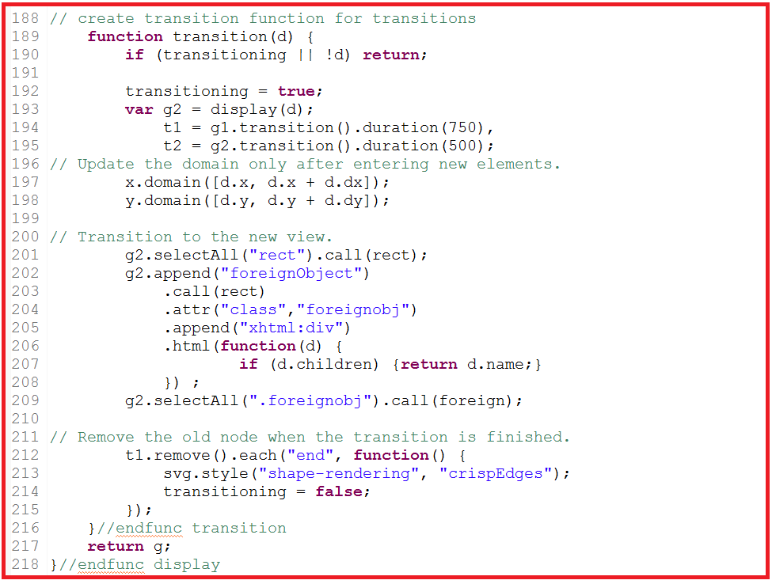

Also write the line highlighted in red with the grandparent/header section. This is required so that you can navigate back to your initial screen by clicking the header section.

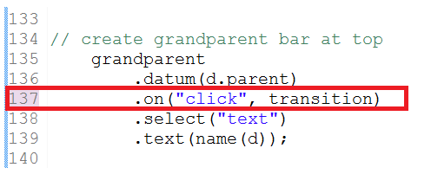

Write this code highlighted in red before the start of function transition

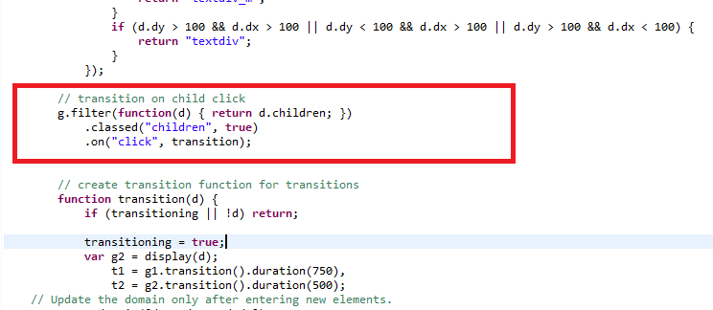

**Question:**

1. **Open the web browser, open your web page, click anywhere in the rectangle Coffee Store/Papa John. Paste the screen shot after navigating to the respective children of the rectangle.**

**Hint:** In order to find the color of the rectangle for a specific parent check the legend. Search for that color on the treemap and then click anywhere on that colored rectangle in the treemap.

**Answer**

**Attach assignments in elearning**

1. Attach the **assignment document (only solutions to questions)**

in Microsoft Word /pdf

1. Submit the eclipse files(html/javascript) after compressing using the industry standard zip(.zip) on eLearning. RAR(.rar) files will not be accepted.